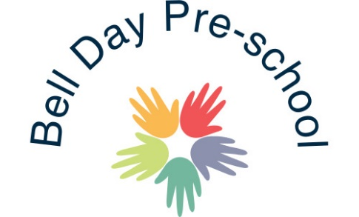

Risk Assessment Policy

The Early Years Foundation Stage requires childcare providers to conduct risk assessments and review them regularly.

We check the pre-school room and garden every morning before the children arrive to ensure that it is a safe environment for the children to learn in.

We also risk assess any environment that we take the children into, for example walking to the park, the shops, library, forest school, P.E etc. If we are planning to take the children into environments that are unknown to us we do try to do a risk assessment in advance so that we are aware of any potential hazards, although this may not always be possible (such as the Zoo or Theatre).

Activities such as cooking are risk assessed to consider allergies, as well as potential dangers such as using knives or cooking equipment, ensuring precautions are put in place prior to the activity.

In depth risk assessments are carried out in accordance with our insurance company policy.

We record our assessments and when these are complete and signed off by management, they are stored in a file. These documents are available for any parent to see on request, as well as Ofsted.

We regularly carry out fire drills, making sure all staff and children are aware of the evacuation process. It is then documented who has taken part in the fire drill.

When discussing fire drills, we have also discussed what we would do as a setting if we became under threat by a terrorist and how we could escape.

March 2020 Reviewed and amended: August 2020

Signed: G.Owers

