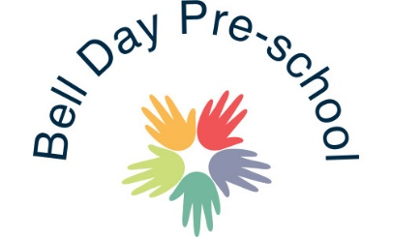
Minibus & Transport
Bell Day Pre-school has use of the Katherine Semar Minibus.
The minibus is kept in good order, with a current MOT certificate, valid insurance and regularly serviced by a reputable company. Bell Day Pre-school now take the Minibus to get cleaned also.
Children in our Pre-school room will use car seats on all but very local trips within Saffron Walden.
Parents may be asked to provide their own car seats to ensure safety if there are insufficient Pre-school seats available for the journey.
Our allocated Pre-school minibus driver is David Law.
March 2020 Reviewed: 03 August 2020

Signed: G. Owers

