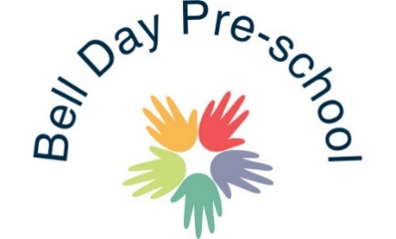
Equal Opportunities Policy
We seek to promote attitudes and behaviour appropriate to living in a multi-cultural society. All adults and children are respected and treated as individuals.
Our aim is that our procedures and practices should not discriminate against or disadvantage anyone on the grounds of ethnic origin, gender, disability, religion, marital status or sexual preference.
This policy statement is always monitored by Managers and Staff.
Employees and Applicants
The Pre-school aims to ensure that individuals are recruited, selected, receive training and promoted based on occupational skill requirements. To the end, Bell Day Pre-school will ensure that no applicant or employee will receive less favorable treatment on the grounds of age, gender. disability, marital status, race, religion, colour, sexuality, cultural or national origin, which cannot be justified as being necessary for the safe and effective performance of the work or training for the work.
Bell Day Pre-school also recognise, acknowledge and welcome all legislation and existing codes of practice produced by the appropriate Commissions for the promotion of equality of opportunity.
The Service
We believe that good childcare should in definition, be non-sexist and non-racist, avoiding stereotypical assumptions about individuals, and groups within society. Employees are committed to applying the principles of equality of opportunity as follows;
- To encourage positive role models, displayed through toys, imaginary play, wall displays, interest tables, personal behaviour and attitudes.
- To promote non-stereotypical role models of men and women, boys and girls in books, posters, attitudes and beliefs.
- To encourage all children to participate in activities, regardless of their sex, race or ability i.e. dressing, home corner, dolls, climbing large apparatus, use of bikes and will make any necessary adaptations for children with needs to access the provisions.
- Regularly review childcare practice to remove those practices that discriminate unfairly on grounds of gender, race, sex or ability.
- We acknowledge that pre-conceptions relating to gender, racism, sexism and ability are abundant within language and to challenge such language where appropriate.
- The Pre-school acknowledges and represents positive images from the diversity of religious practices, cultures, customs, and festivals from around the world that are present in our own multi-cultural society and will provide opportunities for all users of the service to share in these where possible.
- Individuals who do not actively support the equality of opportunity issues outlined in this policy will be challenged by the Bell Pre-school staff and Management.
September 2019 Reviewed: 20th February 2020 Reviewed: 31st July 2020 Reviewed and Updated: July 2021 Signed: G.Owers

