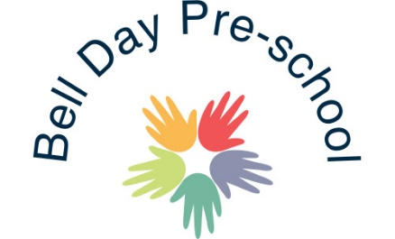

Accident - Incident Policy

We ensure that we have a fully stocked First Aid Kit, which complies with Health and Safety (First Aid) regulations 1981 accessible at all times. We ensure that all our room and garden area is supplied with these Kits. This is stored out of reach of the children. Staff members are required to undertake a First Aid qualification to include First Aid training for infants and young children.

The safety of your child is paramount, and we will take every measure we can to protect your child from hurting him/herself. However, sometimes accidents do happen, and we have written the following procedures on how we will deal with such a situation:

- We will comfort a child and reassure them
- We will assess the extent of their injuries and if necessary, call for medical support/ambulance.
- We will carry out any First Aid procedures that are necessary and that we have been trained to do.
- Once the child is more settled, we will contact you as soon as possible to inform you of the accident and if necessary, to ask you to return to care for your child/take them to the local GP or hospital A & E department.

After every accident, however minor we will:

- Complete an accident report on Famly which then gets sent straight to the parent for acknowledgement.

If the incident requires any medical treatment, then we will:

- Inform Ofsted (under standard 14.3 Children Act Regulation, inform Ofsted about any significant events)
- Fracture/broken bone
- Loss of consciousness
- Pain that is not relieved by simple painkillers
- Acute confused state
- Breathing difficulties or persistent, severe chest pain
- Amputation
- Major dislocation of the shoulder, hip, knee, elbow or spine
- Temporary or permanent loss of eyesight
- Eye injury from chemical or hot metal burns
- Injury from electric shock, electrical burn or hypothermia resulting in unconsciousness, or requiring resuscitation or hospitalisation for more than 24 hours
- Unconsciousness due to asphyxia or exposure to harmful substances, toxins, infected material or biological agents
- Unconsciousness or medical treatment received as a result of inhaling, ingesting or absorbing harmful substances through the skin
- Inform our insurance Company

It is important that you keep us informed regarding your child’s condition following an accident and if you have sought medical advice.

October 2018
Reviewed September 2019 Reviewed and altered: 20/02/2020
Reviewed and altered: 31/07/20
Reviewed and updated: July 2021

Signed: G.Owers

