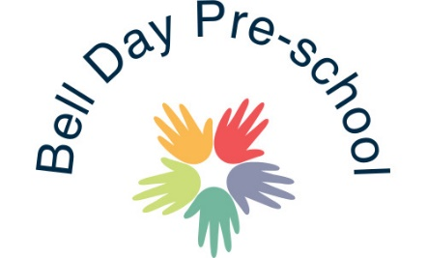
EYPP Policy
The aim of the Early Years Pupil Premium is to close the gap between children from disadvantaged backgrounds and other children by providing additional funding to the setting. As we are committed to ensuring every child reaches their own potential this funding would be used to support the individual children according to their needs.
A child will be eligible for the EYPP if they:
- Are in a low-income family and their parents are in receipt of certain benefits (one or more), for example Child Tax Credit and Income Support;
- Have been adopted from care;
- Have left care through special guardianship;
- Have been looked after by the local authority for at least the span of one day,
- Are subject to a child arrangement order
All children aged three and four who meet the eligibility criteria will benefit from the funding. This funding is paid directly to the setting on an hourly rate basis, linked to claimed funded hours for entitled children, for most children this will be for 15 hours.
In order to be able to claim this funding we require parents to complete the funding agreement which ask for details of parent’s dates of birth and national insurance number or NASS number. This will be sent to you via Gina Owers or the Funding Loop.
As an early-years setting, we are able to choose how we spend the money to best support each individual child. Here are some examples of how the funding may be used:
- Continue our commitment to furthering our knowledge within our continuing professional development by attending relevant training.
- Provide home visits to families
- Creating ‘home learning bags’
- Enhancing ratio and individual support
- Purchasing suitable additional resources
- Buy in any specialist services to support families and children.
Measuring the impact of the EYPP
We are continually reviewing the data we collect on children’s attainment and refreshing our strategies to support children who may not be meeting their individual potential. The practical ideas that are implemented daily are only a few of the strategies used and their success can be monitored through the children’s tracking. Other ways we measure impact include:
- Parent questionnaires
- Informal conversations at the start or the end of a day
- Parent feedback forms provided
- Parents evening consultations
- Success after the implementation of the early help assessments (EHA’s)
Examples of how we have used the funds so far:
Purchasing the Wellcomm pack to support language development
Mindfulness training
Enhanced ratios
Sensory resources

September 2019 Reviewed 20th February 2020 Reviewed: 31st July 2020
Signed: G. Owers

