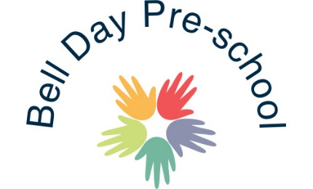
Funded 15 hours policy
As a community interest company Bell Day Pre-school aim to offer the extended entitlement to our families in accordance with the contract with Essex County Council.
The 15 hours are free at point of delivery however, in order to remain sustainable, we reserve the right to implement a charge for the extra services which we provide, as per government regulations included in the publication Early Years Entitlement: operational Guidance as copied below:
Government funding is intended to deliver 15 or 30 hours a week of free, high quality, flexible childcare. IT is not intended to cover the costs of meals, other consumables, additional hours or additional activities. Parents can therefore expect to pay for any meals offered by the provider alongside their free entitlement. Parents can also expect to pay for other consumables or additional activities offered by the provider, such as nappies or trips.
This service charge includes enhanced ratios as well-off site visits such as PE, the library, market, forest school, allotment etc. In addition to this the charge will also cover extra curricula activities in the setting such as Spanish, music sessions, cooking and visitors.
The charge will be reviewed annually, currently 49p per hour. Children in receipt of EYPP will not be requested to this voluntary charge.

September 2019 reviewed 21st February 2020 Reviewed and amended: 31st July 2020
Signed: G. Owers

