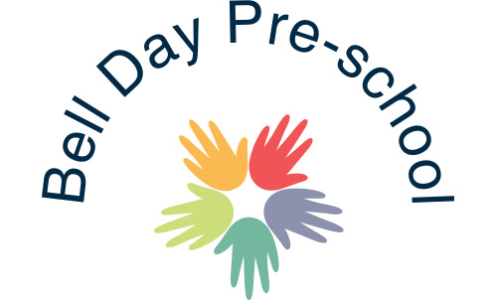
Self Esteem policy

Regarding everything we do with the children in our care, we are working towards building high self-esteem for children and for staff.

In our role as Carers and Educators our aim is to:

- Help children feel valued at all times.
- Ensure that every child feels included in all activities in the setting.
- Help children to share their life experiences with each other and staff in the setting.
- Always portray positive images and objects in non-stereotypical roles.
- Celebrate diversity within the setting and the outside world, using celebrations of other cultures and religions, and bringing these into the settings’ plans.
- Always promote the value of each other to the children.
- In following this policy, it is important that all staff have high self-esteem themselves and believe in the Self-Esteem Policy. If at any time a member of staff feels a lack of self-esteem, as a setting we will look to support and encourage the said person.

This policy has been distributed to all staff.

March 2020 Reviewed: 3rd August 2020

Signed: G.Owers

