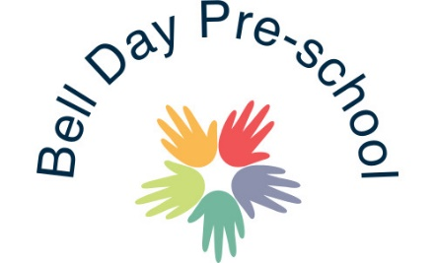

Parental Involvement Policy

We believe that children benefit most from Nursery Education and Care, when parents and nurseries work together in partnership.

We aim to:

- Support parents as their children’s first and most important educators.
- Involve parents in the life of the setting and their children’s education.
- Support parents in their own continuing education and personal development.

In order to fulfil these aims:

- We are committed to ongoing dialogue with parents to improve our knowledge of the needs of their children and to support their families.
- We use Famly for the practitioners and parents to communicate with one another. On here daily activity photos are taken and uploaded. As well as an individual hand over for the day’s events; nappy changes, meal quantities etc.
- Through access to written information and through regular informal communication, we inform all parents about how the setting is run and our policies. We check to ensure parents understand the information which is given to them. If a parent doesn’t understand the forms in which we use, we arrange a meeting and fill the forms in together.
- We inform all parents on a regular basis about their children’s progress using Famly and Parent’s Evenings.
- We involve parents in the shared record keeping about their children- either formally or informally- and to ensure parents have access to their children’s written records. Each parent has their own account on Famly so that they can be updated weekly about their child’s progress and add their own observations.
- We welcome the contributions of parents; in whatever form these may be.
- We inform all parents of the systems for registering queries, complaints of suggestions and check to ensure these are understood. All parents have access to our written complaint’s procedure.
- We provide opportunities for parents to learn about the pre-school curriculum and about young children’s learning, in the setting and at home. We often have open evenings for parents to see the transitions between rooms, potty training evenings and phonics evenings.
- We also invite parents, grandparents and carers in on a regular basis and join as a pre-school.

March 2020 Reviewed and amended: 3rd August 2020

Signed: G.Owers

